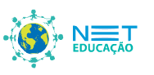 | Ensino Médio  Where Is The Love:  Black Eyed Peas  Inglês Intermediário/Avançado.

Lista de atividades

Where is the Love
Black Eyed Peas

Vocabulary
1. Fill in the blanks with the correct word/words.

What's wrong with the world mama
People 1____________________ like they ain't got no mama
I think the whole world's addicted to the drama
Only attracted to things that will bring you trauma
Overseas, yeah, we tryin' to stop 2_____________________
But we still got terrorists here living in the USA
The big CIA, the Bloods, and the Crips and the KKK

But if you only have 3_________________ for your own race
Then you only leave space to discriminate
And to discriminate only generates 4__________________
And when you hate then you're bound to get irate
Madness is what you demonstrate
And that's exactly how anger works and 5__________________
Man, you got to have love just to set it straight
Take control of your mind and meditate
Let your soul gravitate to the love y'all

[Chorus]
People killing, people dying
Children hurtin', hear them crying
Can you practice what you preach
Or would you turn the other cheek
Father father father father
Send some guidance from above
'Cause people got me, got me questioning
Where is the love

It just ain't the same all the ways of change
New days are strange
Is the world 6________________
If love and peace is so strong
Why the pieces of love don't belong
Nations dropping bombs
Chemical gases filling lungs of little ones
With ongoing suffering as the youth are young
So ask yourself is the lovin' really gone
So I can ask myself really what is going 7_________________
The world that we're living in
People keep on giving in
Making wrong decisions only visions of the dividend
Not respecting each other
Denying thy brother
A war going on, but the 8________________ undercover
The truth is kept secret
It's swept under the rug
If you never know truth then you never know love
Where's the love y'all, c'mon, I don't know
Where's the truth y'all, c'mon, I don't know
Where's the love y'all

[Chorus]

I feel the weight of the world on my shoulder
As I'm gettin' older y'all people gets colder
Most of us only care about money makin'
Selfishness got us 9___________________ the wrong direction
Wrong information always shown by the media
Negative images is the main criteria
Infecting the young minds faster than bacteria
Kids want to act like what they see in the cinemas

Whatever happened to the values of humanity
Whatever happened to the fairness and equality
Instead of spreading love
We spreading animosity
Lack of 10______________________
Leading us away from unity
That's the reason why sometimes I'm feelin' under
That's the reason why sometimes I'm feelin' down
It's no wonder why sometimes I'm feelin' under
Gotta keep our faith alive 'till love is found

[Chorus]

2. Complete the table with the meaning of the words below.
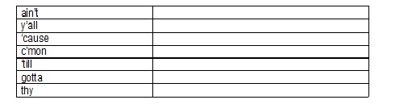

3. Match the word with its meaning.
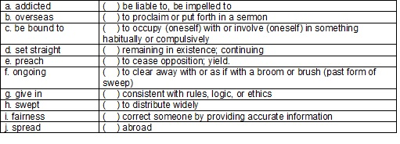

Plano de Aula: Profa. Kátia Maria Pereira.

